CHAPTER 1

INTRODUCTION

Overview
Public infrastructure plays a significant role in maintaining public safety, hygiene, transportation, and the overall quality of life in urban and rural communities. Facilities such as roads, streetlights, water supply systems, electricity services, and sanitation management are essential for the smooth functioning of society. However, citizens frequently face issues such as potholes, damaged roads, water leakage, streetlight failures, irregular waste collection, electricity interruptions, and drainage problems. These problems not only create inconvenience for the public but also affect the efficiency and development of cities. In many places, the traditional method of reporting such complaints is still carried out manually through office visits, phone calls, or written applications. This process is often time-consuming, lacks transparency, and results in delayed responses and poor coordination between citizens and municipal authorities.
To overcome these limitations, CityFix: Public Infrastructure Complaint Management System has been developed as a web-based platform that simplifies and digitizes the complaint management process. Users can enter complaint details, select the appropriate category, assign priority levels, and provide location information for faster identification and resolution of problems. In addition, the system enables citizens to track the real-time status of their complaints, improving communication, accountability, and transparency between the public and municipal departments.
The CityFix application is developed using the MERN Stack, which includes MongoDB, Express.js, React.js, and Node.js. React.js is used to design a responsive, interactive, and user-friendly frontend interface, ensuring smooth user experience across devices. Node.js and Express.js are utilized for backend development, API handling, and server-side operations. MongoDB Atlas serves as the cloud-based database system that securely stores user information, complaint records, department details, and status updates. The system architecture is designed to be scalable, secure, and efficient for handling a large number of users and complaints.
The application follows a hierarchical administrative structure consisting of one Super Admin and five department admins. Each department admin is responsible for handling complaints related to a specific department such as Streetlight, Sanitation, Electricity, Road, and Water Supply. The Super Admin monitors the overall functioning of the system and assigns complaints to the relevant departments for quick resolution. Department admins can update the complaint status, resolution progress, and completion details, allowing citizens to stay informed throughout the process.
The proposed CityFix system offers several advantages over traditional complaint management methods. It reduces paperwork, minimizes manual effort, speeds up complaint processing, and ensures proper record maintenance. The system also improves transparency, accountability, and communication between citizens and authorities. By providing a centralized, secure, and user-friendly platform, CityFix contributes to efficient civic administration and enhances citizen satisfaction through effective public infrastructure complaint management.

Objectives
The aim of this project is to design and develop a full-stack web-based application that efficiently manages and monitors public infrastructure complaints through a centralized digital platform. The system focuses on improving communication between citizens and municipal authorities while ensuring transparency, faster complaint resolution, and efficient department-wise complaint handling.
- To provide an online platform for citizens to register complaints related to Streetlight, Sanitation, Electricity, Road, and Water infrastructure issues.
- To implement a centralized complaint management system with one Super Admin and multiple department admins for monitoring, assigning, and resolving complaints efficiently.
- To enable real-time complaint tracking and status updates, allowing users to monitor the progress of their complaints through different stages.
- To design a user-friendly and responsive interface that simplifies complaint registration, management, and communication between citizens and authorities.

CHAPTER 2

SYSTEM REQUIREMENTS

Functional Requirements
The functional requirements focus on enabling efficient registration, management, and tracking of public infrastructure complaints through a centralized web platform. The system integrates complaint handling workflows, department-wise administration, real-time status tracking, and full-stack web technologies to provide reliable communication and effective complaint resolution between citizens and municipal authorities.
- User Registration and Login: The system provides secure registration and login functionality for citizens, Super Admin, and department admins using authentication credentials and role-based access control.
- Complaint Registration: Enable users to submit complaints by entering complaint title, description, category, priority level, and location details through the web interface.
- Department-wise Complaint Management: Allow the Super Admin to monitor all complaints and assign them to the appropriate department admins related to Streetlight, Sanitation, Electricity, Road, and Water departments.
- Complaint Status Tracking: Enable users to track complaint progress through different stages such as Pending, Assigned, In-Progress, and Resolved in real time.
- Department Admin Operations: Department admins can view assigned complaints, update complaint statuses, manage complaint resolution, and monitor complaint progress within their respective departments.
- Dashboard and Complaint Monitoring: Provide dashboards for users and administrators to view complaint statistics, complaint history, and management details.
- Database Management: Store and retrieve user details, complaint records, department information, and status updates securely using MongoDB Atlas.
- Error Handling and Validation: Handle invalid inputs, incomplete complaint details, unauthorized access, and system errors by providing appropriate feedback messages to users.

  - Non – Functional Requirements
The non-functional requirements define the quality, performance, reliability, and usability characteristics of the system. These requirements ensure that the Public Infrastructure Complaint Management System operates efficiently, securely, and reliably for both citizens and administrators.
• User-Friendly Interface: The system should provide a simple, interactive, and easy-to-use interface for citizens and administrators to access system functionalities efficiently.
• Performance: The application should process requests and display complaint information with minimal response time to ensure smooth user experience.
• Security: The system should ensure secure authentication, role-based access control, and protection of user and complaint data from unauthorized access.
• Reliability: The system should provide consistent and accurate complaint management operations without data loss or system failure.
• Scalability: The application should be capable of handling an increasing number of users, complaints, and departments without affecting system performance.
• Availability: The system should remain accessible and operational whenever users or administrators need to access complaint-related services.
• Maintainability: The system should be designed in a modular and organized manner to allow easy maintenance, updates, and future enhancements.
• Compatibility: The application should support different web browsers and devices to provide accessibility across multiple platforms.

  - Software Requirements
The software requirements for the CityFix: Public Infrastructure Complaint Management System include modern web technologies and libraries for frontend development, backend services, authentication, and database management. These technologies ensure efficient complaint handling, secure communication, and smooth interaction between citizens and administrators.
- Operating System: Windows / Linux / macOS
- IDE: Visual Studio Code
- Frontend Technologies: React.js, Tailwind CSS, React Router DOM
- Backend Technologies: Node.js, Express.js
- Database: MongoDB Atlas
- Libraries and Frameworks:
i. Mongoose (database interaction and schema management)
ii. JWT Authentication (secure login and role-based access control)
iii. Axios (frontend and backend API communication)
iv. Tailwind CSS (responsive UI styling)
v. React Router DOM (navigation and page routing)

  - Hardware Requirements
The hardware requirements for the CityFix system ensure smooth execution of frontend operations, backend services, database connectivity, and user interaction through the web interface.
- Processor: Intel i3 or higher
- Processor Speed: 2.0 GHz or above
- RAM: Minimum 4 GB (8 GB recommended)
- Hard Disk Space: 1 GB or more free space
- Display: Standard monitor with web browser support
- Network: Stable internet connection for accessing the application and database

CHAPTER 3
ARCHITECTURE

System Flow Diagram

The system flow diagram Figure 3.1 illustrates the overall workflow and functioning of the CityFix: Public Infrastructure Complaint Management System. It represents the interaction between citizens, Super Admin, department admins, departments, and the database during the complaint management process. The diagram explains how complaints are registered, processed, assigned, tracked, and resolved within the system. It also demonstrates the flow of information and real-time status updates between different modules of the application.

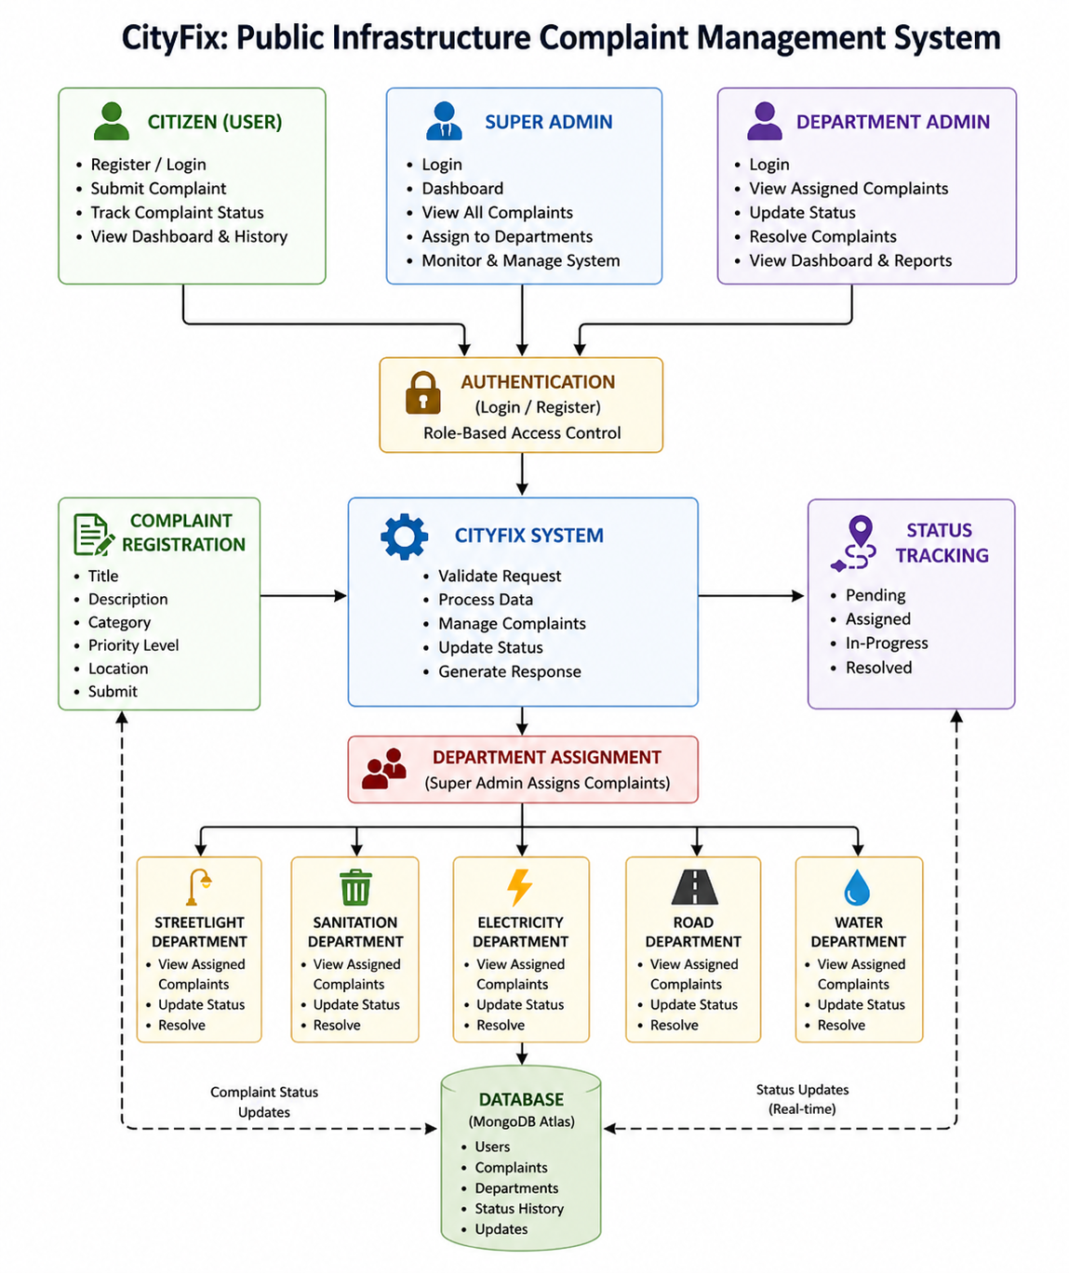

Figure 3.1: Flow Diagram

- Citizen (User): The citizen is the primary user of the system who can register and log into the platform securely. Citizens can submit complaints related to public infrastructure issues such as Streetlight, Sanitation, Electricity, Road, and Water problems. They can also track complaint status and view complaint history through the dashboard.
- Super Admin: The Super Admin is responsible for managing the overall system operations. The Super Admin can monitor all complaints submitted by users, assign complaints to the appropriate departments, and supervise complaint handling activities across the system.
- Department Admin: Department admins are responsible for handling complaints related to their respective departments. They can log into the system, view assigned complaints, update complaint statuses, resolve complaints, and monitor department-related activities.
- Authentication: The authentication module provides secure login and registration functionality for all users. It ensures role-based access control by verifying user credentials and providing authorized access to system functionalities.
- Complaint Registration: The complaint registration module allows citizens to submit complaints by entering complaint title, description, category, priority level, and location details. The complaint information is then forwarded to the system for processing and storage.
- CityFix System: The CityFix system acts as the core processing unit of the application. It validates user requests, processes complaint information, manages complaint workflows, updates statuses, and generates responses for users and administrators.
- Status Tracking: The status tracking module enables users to monitor complaint progress in real time. Complaints move through different stages such as Pending, Assigned, In-Progress, and Resolved, ensuring transparency in complaint handling.
- Department Assignment: The department assignment module allows the Super Admin to assign complaints to the appropriate departments based on the complaint category. This ensures proper complaint distribution and efficient issue resolution.
- Streetlight Department: The Streetlight department handles complaints related to damaged or non-functioning streetlights. Department admins can view assigned complaints, update statuses, and resolve issues.
- Sanitation Department: The complaints related to waste management and cleanliness, and admins are responsible for processing and resolving these issues.

- Electricity Department: The Electricity department handles complaints related to power failures, damaged electrical equipment, and electricity supply issues.
- Road Department: The Road department is responsible for handling complaints related to damaged roads, potholes, and road maintenance issues. Complaints are monitored and resolved by the department admin.
- Water Department: The Water department handles complaints related to water supply, leakage, and drainage problems. Department admins manage complaint resolution and status updates.
- Database (MongoDB Atlas): MongoDB Atlas is used as the cloud database for securely storing user details, complaint records, department information, and complaint status history. The database supports efficient data retrieval and management.
- Complaint Status Updates: The complaint status update mechanism provides real-time updates between the departments, database, and users. It ensures transparency and effective communication throughout the complaint resolution process.

3.2 System Design Explanation
The CityFix: Public Infrastructure Complaint Management System is built as a role-based, modular web application designed to manage public complaints efficiently through a structured workflow. It follows a client–server architecture where the frontend is responsible for user interaction, the backend handles business logic and processing, and the database stores all persistent application data. The system is designed to support multiple user roles such as Citizen, Super Admin, and Department Admin, each assigned specific permissions to ensure smooth workflow management, accountability, and secure access control.
The system implements Role-Based Access Control (RBAC) to restrict and manage user permissions effectively. Citizens can register complaints and track their status, Super Admins are responsible for monitoring all complaints and assigning them to appropriate departments, and Department Admins handle and resolve the assigned complaints. This ensures that each user interacts only with authorized functionalities, improving system security and maintaining proper data control.
CityFix follows a layered architecture, which is divided into three main layers. The presentation layer (frontend) provides an interactive interface for users to submit and track complaints. The application layer (backend) processes user requests, handles authentication, manages complaint workflows, and implements business logic. The data layer consists of the database, which securely stores all system data, including user details, complaints, and status updates. This separation of layers enhances system scalability, maintainability, and performance.
Communication between different modules is managed through RESTful APIs, enabling smooth, fast, and secure data exchange between the frontend and backend of the system. Whenever a citizen submits a complaint, the request is sent from the React.js frontend to the Node.js and Express.js backend through API calls, where the data is validated, processed, and securely stored in the MongoDB Atlas database. Similarly, actions such as complaint assignment, priority updates, status changes, and resolution tracking are also handled through APIs. This ensures real-time synchronization of information across all modules and provides consistent data flow between citizens, department admins, and the Super Admin. The API-based architecture also improves system scalability, maintainability, and overall performance while supporting efficient communication between different components of the application. The system also incorporates workflow automation, where complaints move through predefined stages such as Submitted, Assigned, In Progress, and Resolved. This automated workflow reduces manual intervention, improves efficiency, and ensures faster resolution of complaints.
MongoDB Atlas is a cloud-based NoSQL database used in the system to securely store and manage all types of application data such as user details, complaint records, department information, and complaint status history. It follows a document-oriented structure where data is stored in flexible JSON-like formats, allowing easy handling of dynamic and varying complaint information. This makes it highly suitable for real-world complaint systems where data fields may differ based on category and requirements. MongoDB Atlas provides high scalability, real-time data access, and strong security features such as encryption, role-based access control, and automated backups. In CityFix, MongoDB efficiently supports fast data retrieval and continuous updates, enabling users to track complaint status in real time and ensuring smooth communication between citizens, admins, and department.
CHAPTER 4
METHODOLOGY

Tools and Libraries Used:

The CityFix: Public Infrastructure Complaint Management System is developed using a modern web development technology stack that ensures scalability, performance, and ease of maintenance. The system is built using a combination of frontend technologies, backend technologies, database, and supporting libraries that work together to provide a smooth user experience and efficient complaint management workflow.

- Frontend(React.js, React Router DOM, Tailwind CSS, React Icons, React Toastify, Leaflet.js)
The frontend technologies of the CityFix system is developed using React.js, which provides a component-based architecture for building a dynamic and responsive user interface. React Router DOM is used to manage navigation between different modules such as login, dashboard, complaint registration, and status tracking. Tailwind CSS is used for styling, enabling a modern, responsive, and consistent design across the application. React Icons enhance the UI with intuitive icons, while React Toastify is used to display real-time notifications for actions like complaint submission and status updates. Additionally, Leaflet.js is integrated to provide interactive map functionality for capturing and displaying complaint locations.
- Backend(Node.js,Express.js)
The backend technologies of the system is built using Node.js as the runtime environment and Express.js as the web framework. These technologies are responsible for handling API requests, managing server-side logic, processing complaint data, and ensuring smooth communication between the frontend and database. The backend also manages authentication, role-based access control, complaint assignment, status updates, and workflow processing, ensuring efficient system operations.

- Database(MongoDB Atlas, Mongoose)
MongoDB Atlas is used as the cloud-based NoSQL database for storing all application data, including user information, complaints, department details, and complaint status history. It provides scalability, real-time data access, and high availability through cloud infrastructure. Mongoose is used as an Object Data Modeling (ODM) library, which provides schema-based data modeling and simplifies interactions between the Node.js backend and MongoDB database.
- Authentication and Security
The system implements secure authentication mechanisms to ensure that only authorized users can access the platform. Role-based access control (RBAC) is used to define permissions for Citizens, Super Admins, and Department Admins. Passwords are securely stored using encryption techniques to protect user data.

  - User Interface Description
The user interface of the CityFix: Public Infrastructure Complaint Management System is designed with a strong focus on simplicity, usability, and accessibility to ensure that all types of users, including citizens and administrators, can easily interact with the system without technical difficulty. The interface is developed using React.js, which enables a dynamic and component-based structure, and is styled using Tailwind CSS, ensuring a clean, modern, and fully responsive design that adapts seamlessly to different screen sizes such as desktops, tablets, and mobile devices. The overall design emphasizes clarity, smooth navigation, and an organized layout so that users can quickly access required features without confusion.

The Citizen User Interface is the primary interaction point for users of the system. It allows citizens to securely register and log in to the platform. After authentication, users are redirected to a personalized dashboard where they can submit complaints related to various public infrastructure issues such as roads, water supply, electricity, sanitation, and streetlights. While submitting a complaint, users are required to provide important details such as complaint category, description, location information, and priority level.

The interface also includes an interactive complaint tracking section where users can monitor the real-time status of their complaints. Additionally, citizens can view their complete complaint history, which helps them keep track of previously submitted issues and their resolutions. Status indicators such as “Pending,” “Assigned,” “In Progress,” and “Resolved” are clearly displayed to ensure transparency.

The Administrative Interfaces, which include the Super Admin and Department Admin dashboards, are designed for efficient management and control of the entire complaint system. The Super Admin interface provides a centralized view of all complaints submitted in the system, allowing monitoring, verification, and assignment of complaints to the appropriate departments based on their category. It also helps in overseeing the overall system performance and ensuring that complaints are processed efficiently. The Department Admin interface, on the other hand, is role-specific and displays only those complaints that are assigned to a particular department. Department admins can update complaint statuses, add remarks, and mark complaints as resolved once the issue is addressed. In addition, real-time notifications and status updates are integrated into the system, ensuring continuous communication between citizens and administrators. This structured and well-organized interface design improves workflow efficiency, enhances user experience, and ensures transparency throughout the complaint management process
  - Test Cases
Testing is an important phase in the development of the CityFix system, as it ensures that all modules and functionalities operate correctly, efficiently, and without errors. The testing process was carried out to verify that the system meets user requirements and performs reliably under different conditions. Various components such as user authentication, complaint submission, complaint tracking, dashboard operations, database connectivity, and administrative functionalities were thoroughly tested. The objective of testing was to identify bugs, validate data flow, improve system stability, and ensure a smooth user experience.
The CityFix system was tested using multiple scenarios involving valid inputs, invalid inputs, boundary conditions, and real-time operations. Functional testing was performed to confirm that users could successfully register, log in, submit complaints, and track complaint progress. Similarly, the admin modules were tested to ensure that complaints could be assigned to departments, updated with status changes, and managed effectively. Database testing was conducted to confirm that all complaint records, user information, and status updates were correctly stored and retrieved from MongoDB Atlas without data loss.
The following table presents a set of test cases used to evaluate the performance and correctness of the CityFix system.
Case No. | Test Scenario | Expected Result | Actual Result | Status
1 | User Login with valid credentials | User should be redirected to dashboard | Dashboard loaded successfully | Pass
2 | User Login with invalid credentials | Error message should be displayed | Error message displayed | Pass
3 | Create New Complaint | Complaint should be submitted and stored | Complaint successfully created | Pass
4 | View Complaint Dashboard | All complaints should be listed with status | Complaints displayed correctly | Pass
5 | Complaint Status Tracking | Status should update dynamically | Status updated correctly | Pass
6 | Admin Login | Admin should access admin dashboard | Admin dashboard displayed | Pass
7 | Assign Complaint to Department | Complaint should be assigned successfully | Assignment completed | Pass
8 | View Complaint Details | Full complaint details should be shown | Details displayed correctly | Pass
9 | Database storage | Detection is saved in database | Data stored successfully | Pass
Table 4.1: Test Cases
CHAPTER 5
RESULTS
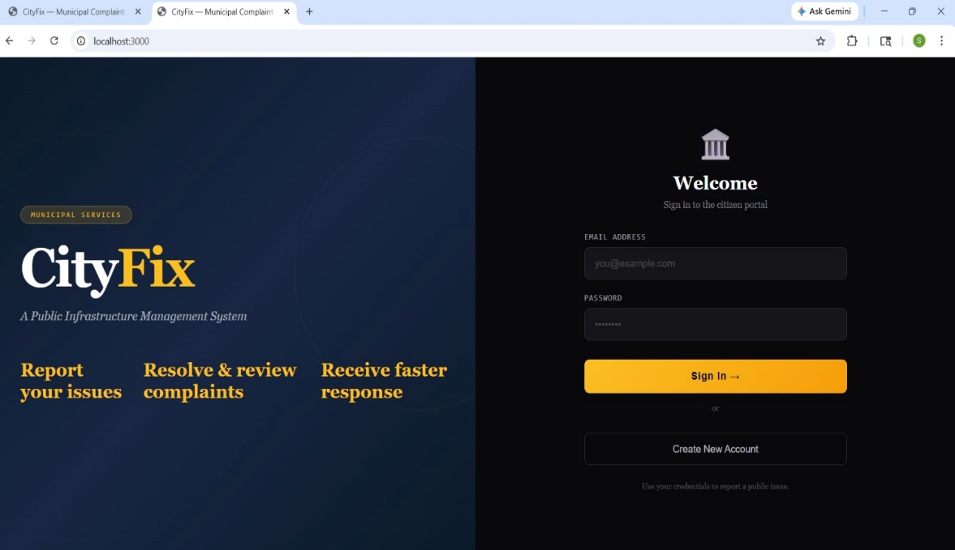
5.1 Snapshots
Snapshot 5.1: Login Page Interface
Snapshot 5.1 shows the login interface of the CityFix system. Users can enter their email and password to access the platform, with options for login and new account registration.
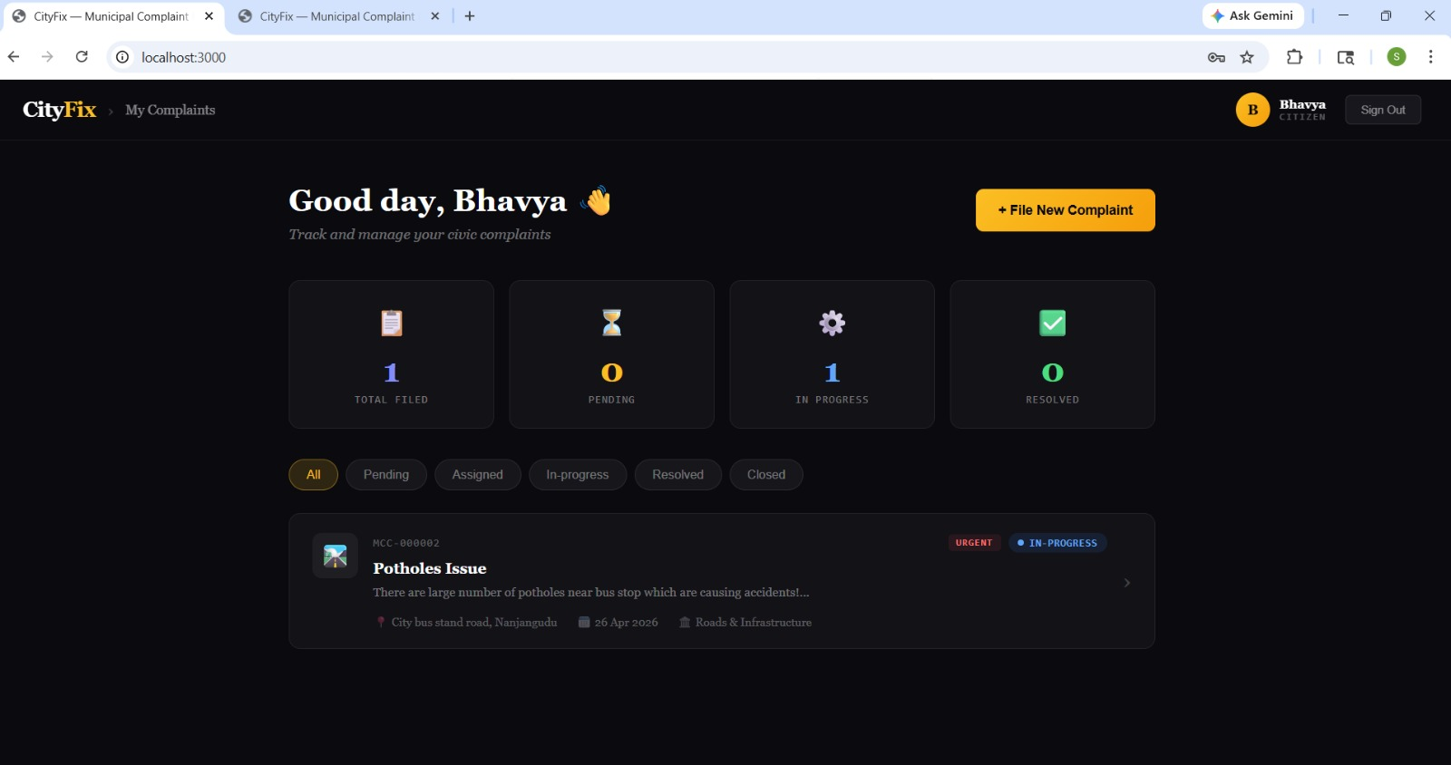

Snapshot 5.2: User Dashboard
Snapshot 5.2 displays the user dashboard after login. It provides an overview of complaints and allows users to file new complaints and filter them based on status.
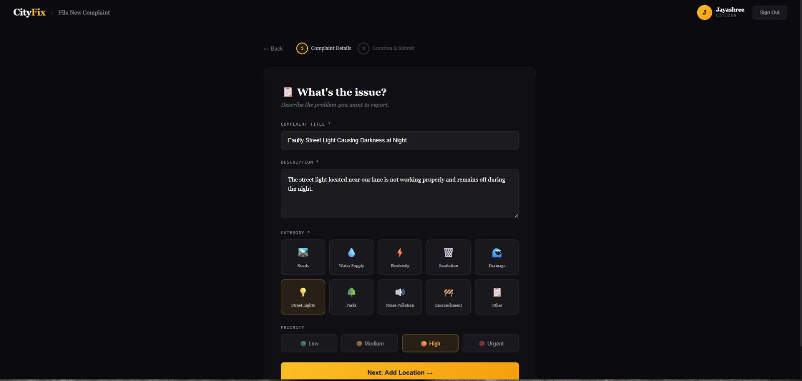
Snapshot 5.3: Complaint Submission Form
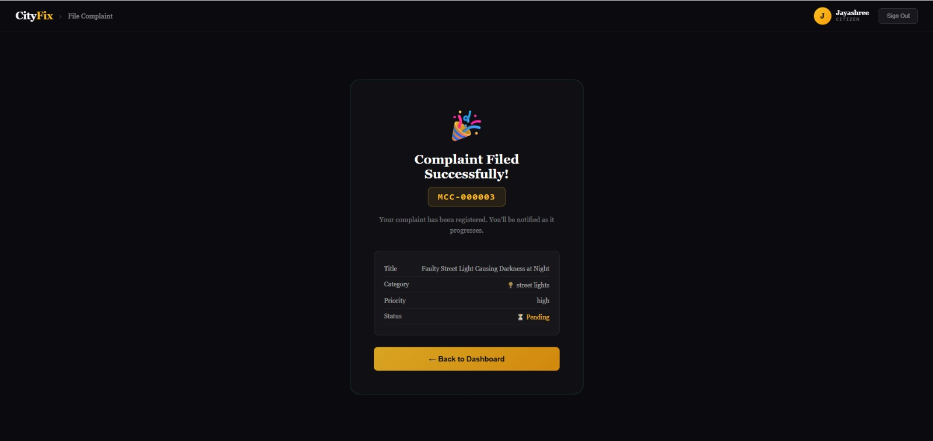
Snapshot 5.3 shows the complaint filing interface where users enter details such as title, description, category, and priority. The system ensures structured input collection and allows users to categorize issues like roads, electricity, sanitation, etc.
Snapshot 5.4: Complaint Filed Successfully
Snapshot 5.4 confirms successful complaint submission. A unique complaint ID is generated, and details such as title, category, priority, and status are displayed. This ensures transparency and tracking capability.

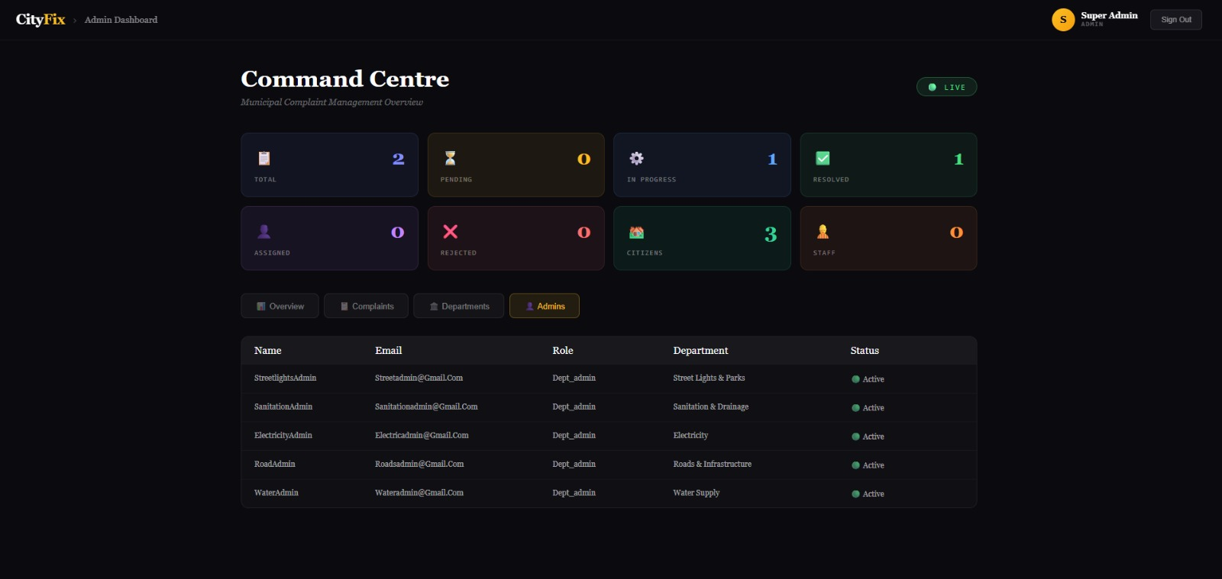
Snapshot 5.5: Admin Dashboard
Snapshot 5.5 shows the admin panel where authorities monitor and manage complaints. It includes statistics like total complaints, pending, resolved, and citizen count. Admins can also manage departments and users.
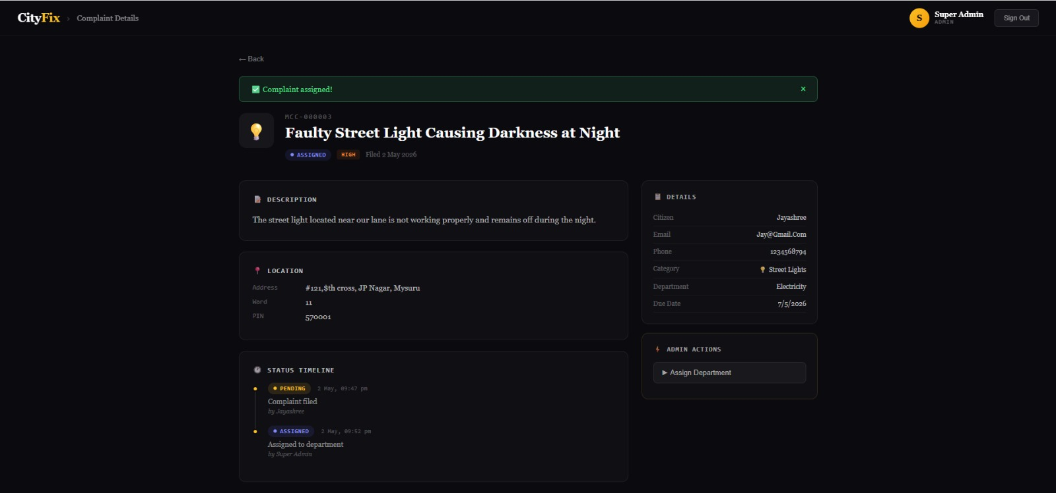
Snapshot 5.6: Complaint Details View (Admin Side)

Snapshot 5.6 shows detailed complaint information including description, location, citizen details, and status timeline. Admins can assign complaints to departments and track progress.

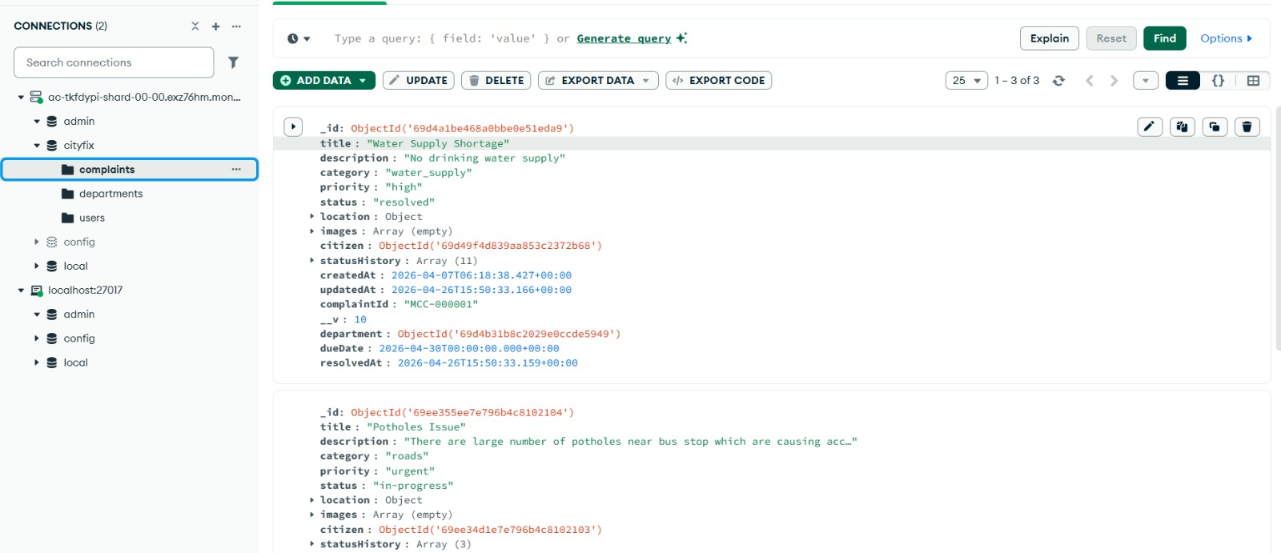
Snapshot 5.7: Database Storage (MongoDB)

Snapshot 5.7 shows the MongoDB database where complaint data is stored. It includes fields such as complaint title, description, category, priority, status, and timestamps, confirming proper backend integration.
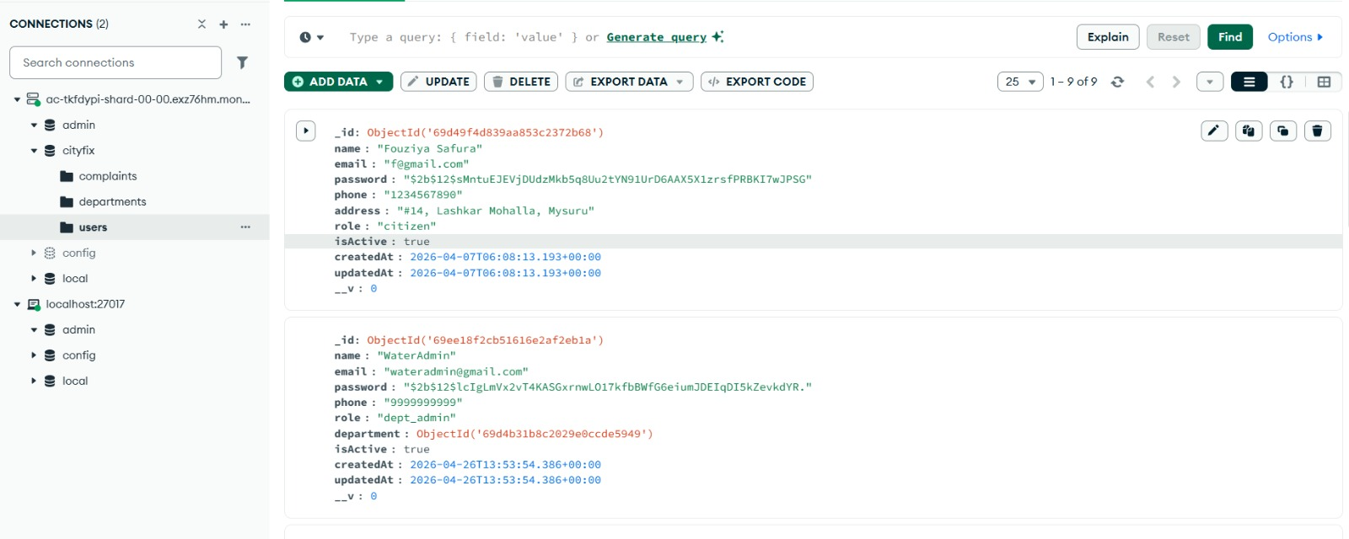
Snapshot 5.8: Users Collection (MongoDB Database)

Snapshot 5.8 shows the users collection in the MongoDB database. It contains details of registered users such as name, email, password (encrypted), role, and contact information. This confirms that user data is securely stored and managed, supporting authentication and role-based access in the system.
CONCLUSION
The CityFix system provides an effective solution for managing urban civic issues through a full-stack web application. Developed using React, Node.js, Express.js, and MongoDB, the system allows users to register, log in, submit complaints, and track their status efficiently. Complaints are securely stored in the database, while the admin module helps authorities manage and resolve issues effectively.
The system performs reliably across different test cases and includes features such as input validation, image upload, and real-time status updates, improving usability and transparency. The user-friendly interface makes the application easy to use for both citizens and administrators.
Overall, the CityFix project successfully achieves its objective of creating a smart complaint management system. It demonstrates the practical implementation of full-stack development concepts and provides scope for future enhancements such as mobile integration, GPS tracking, and AI-based complaint categorization.

REFERENCES

1. Google – Used for collecting technical information and references.
2. ChatGPT – Used for documentation and coding assistance.
3. MongoDB Documentation – Used for database development and integration.
4. React Documentation – Used for frontend development and UI design.
5. Node.js Documentation – Used for backend server development.
6. Express.js Documentation – Used for API creation and routing.
7. MongoDB Atlas – Used for cloud database storage.
8. GitHub – Used for code hosting and version control.

